CPE301 – SPRING 2019
Design Assignment 6

Student Name: Tian Chen
Student #: 2001086575
Student Email: chent5@unlv.nevada.edu
Primary Github address: https://github.com/Chentian12138/AAAABBBBB
Directory:DA6

Submit the following for all Labs:
- In the document, for each task submit the modified or included code (only) with highlights and justifications of the modifications. Also, include the comments.
- Use the previously create a Github repository with a random name (no CPE/301, Lastname, Firstname). Place all labs under the root folder ESD301/DA, sub-folder named LABXX, with one document and one video link file for each lab, place modified asm/c files named as LabXX-TYY.asm/c.
- If multiple asm/c files or other libraries are used, create a folder LabXX-TYY and place these files inside the folder.
- The folder should have a) Word document (see template), b) source code file(s) and other include files, c) text file with youtube video links (see template).

- COMPONENTS LIST AND CONNECTION BLOCK DIAGRAM w/ PINS

Atmega 328p and mpu 6050
- INITIAL/MODIFIED/DEVELOPED CODE OF TASK 1/A

/*
* DA 6.c
*
* Created: 5/5/2019 11:46:25 PM
* Author : chent
*/

#define F_CPU 16000000UL // Board running at 16MHz
#include <avr/io.h>
#include <util/delay.h>
#include <inttypes.h>
#include <stdlib.h>
#include <stdio.h>

#include "MPU6050_res_define.h" //
#include "I2C_Master_H_file.h" // Include necessary libraries
#include "USART_RS232_H_file.h" //

double acc_X; //
double acc_Y; //
double acc_Z; // Declare all variables for Accelerometer and Gyroscope
double gyro_X; //
double gyro_Y; //
double gyro_Z; //

void MPU6050_Init() // Gyro initialization function
{
_delay_ms(150); // power up time
I2C_Start_Wait(0xD0); // start with device write address
I2C_Write(SMPLRT_DIV); // write to sample rate register
I2C_Write(0x07); // 1KHz sample rate
I2C_Stop();

I2C_Start_Wait(0xD0); // start with device write address
I2C_Write(PWR_MGMT_1); // write to power management register
I2C_Write(0x01); // Reference frequency of X axis gyroscope
I2C_Stop();

I2C_Start_Wait(0xD0); // start with device write address
I2C_Write(CONFIG); // write to configuration register
I2C_Write(0x00); // Fs = 8KHz
I2C_Stop();

I2C_Start_Wait(0xD0); // start with device write address
I2C_Write(GYRO_CONFIG); // write to Gyro configuration register
I2C_Write(0x18); // Celsius +/- 2000 degrees
I2C_Stop();

I2C_Start_Wait(0xD0); // start with device write address
I2C_Write(INT_ENABLE); // rite to interrupt enable register
I2C_Write(0x01);
I2C_Stop();
}

void MPU_Start_Loc()
{
I2C_Start_Wait(0xD0); // I2C start with device write address
I2C_Write(ACCEL_XOUT_H); // Write start location address from where to read
I2C_Repeated_Start(0xD1); // I2C start with device read address
}

void Read_RawValue()
{
MPU_Start_Loc(); //
accelerometer_X = (((int)I2C_Read_Ack()<<8) | (int)I2C_Read_Ack()); //
accelerometer_Y = (((int)I2C_Read_Ack()<<8) | (int)I2C_Read_Ack()); //
accelerometer_Z = (((int)I2C_Read_Ack()<<8) | (int)I2C_Read_Ack()); // read value of Gyroscope
gyroscope_X = (((int)I2C_Read_Ack()<<8) | (int)I2C_Read_Ack()); //
gyroscope_Y = (((int)I2C_Read_Ack()<<8) | (int)I2C_Read_Ack()); //
gyroscope_Z = (((int)I2C_Read_Ack()<<8) | (int)I2C_Read_Nack()); //
I2C_Stop();
}

int main()
{
char buffer[20], float_[10];
float Xa,Ya,Za;
float Xg=0,Yg=0,Zg=0;
I2C_Init(); // initialize I2C
MPU6050_Init(); // initialize MPU6050
USART_Init(9600); // initialize USART with 9600 baud rate

while(1)
{
Read_RawValue();

Xa = acc_X/16384.0; // To obtain real values, divide raw value by scale factor
Ya = acc_Y/16384.0;
Za = acc_Z/16384.0;

Xg = gyro_X/16.4;
Yg = gyro_Y/16.4;
Zg = gyro_Z/16.4;

dtostrf( Xa, 3, 2, float_ );
sprintf(buffer," Ax = %s g\t",float_);
USART_SendString(buffer);

dtostrf( Ya, 3, 2, float_ );
sprintf(buffer," Ay = %s g\t",float_);
USART_SendString(buffer);

dtostrf( Za, 3, 2, float_ );
sprintf(buffer," Az = %s g\t",float_);
USART_SendString(buffer);

dtostrf( Xg, 3, 2, float_ );
sprintf(buffer," Gx = %s%c/s\t",float_,0xF8);
USART_SendString(buffer);

dtostrf( Yg, 3, 2, float_ );
sprintf(buffer," Gy = %s%c/s\t",float_,0xF8);
USART_SendString(buffer);

dtostrf( Zg, 3, 2, float_ );
sprintf(buffer," Gz = %s%c/s\r\n",float_,0xF8);
USART_SendString(buffer);
_delay_ms(1000);
}
}
- SCHEMATICS

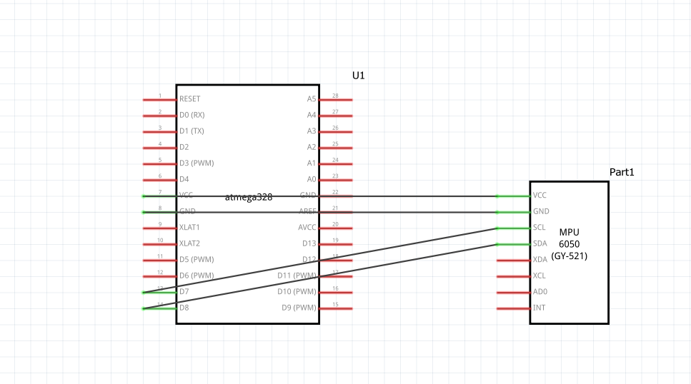

- SCREENSHOTS OF EACH TASK OUTPUT (ATMEL STUDIO OUTPUT)
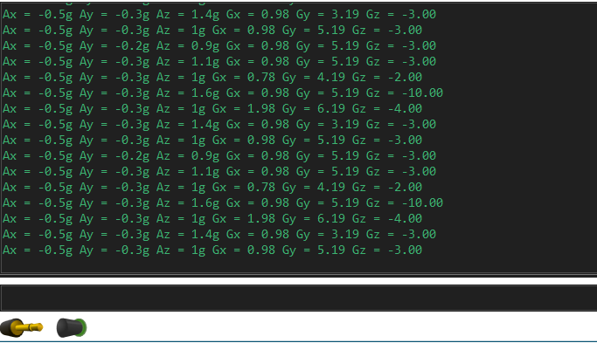

- SCREENSHOT OF EACH DEMO (BOARD SETUP)

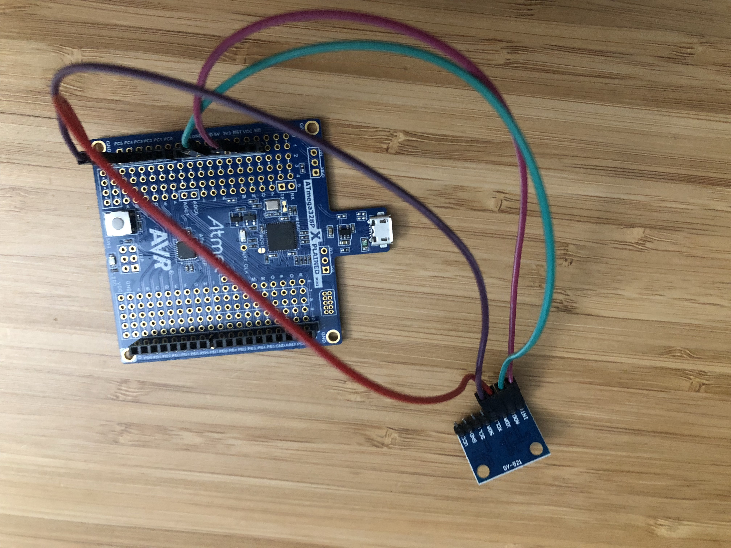

- GITHUB LINK OF THIS DA
https://github.com/Chentian12138/AAAABBBBB

Student Academic Misconduct Policy
http://studentconduct.unlv.edu/misconduct/policy.html

“This assignment submission is my own, original work”.
NAME OF THE STUDENT

